### Project Name: Sales Automobile Using Salesforce CRM

Team ID: LTVIP2024TMID11576

Team Leader: V Shilpa

Team member: V Tejasree

### Apex Schedulers

**Delete Opportunity Schedule Class**

**Objective :**

* Through this schedulable class, we can see all the Closed Lost Opportunities.
* We can delete all the Closed lost Opportunities by this Scheduled method on every monday as weekly.

1. Login to the respective account and navigate to the gear icon in the top right corner.
2. Click on the Developer console. Now you will see a new console window.
3. In the toolbar, you can see FILE. Click on it and navigate to new and create New apex class.
4. Name the class as “DeleteClosedLostOpportunities ”

**CODE SNIPPET :**

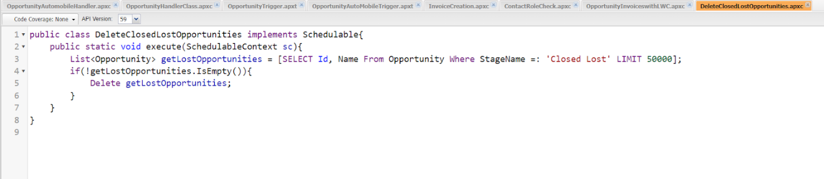

public class DeleteClosedLostOpportunities implements Schedulable{

    public static void execute(SchedulableContext sc){

        List<Opportunity> getLostOpportunities = [SELECT Id, Name From Opportunity Where StageName =: 'Closed Lost' LIMIT 50000];

        if(!getLostOpportunities.IsEmpty()){

            Delete getLostOpportunities;

        }

    }

}

**Schedule the Apex class:**

* Go to the Home page in your salesforce account.
* In the search bar, enter Apex and click on Apex Classes.  
  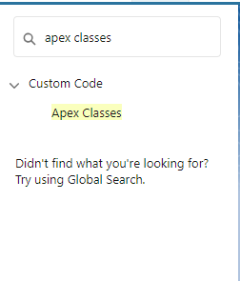  
  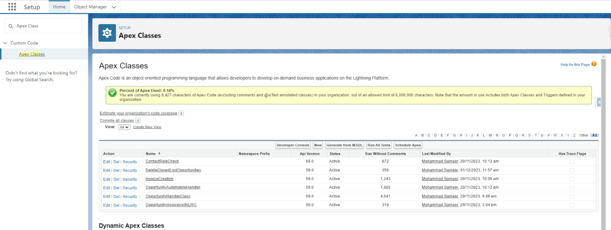
* Click on Schedule Apex and enter the Job name.
  + Job Name : DeleteOpportunitySchedule  
    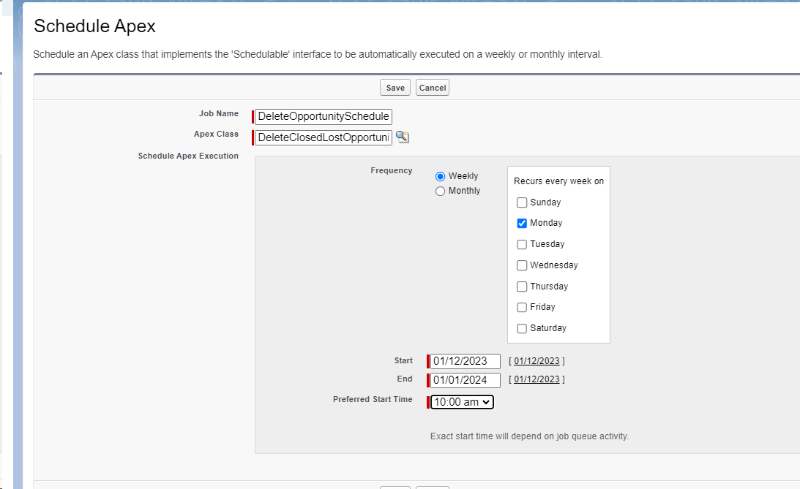

1. Now click on the search icon present near the  Apex class : Goto the Lookup icon beside ? click on it ? select    DeleteClosedLostOpportunities.  
   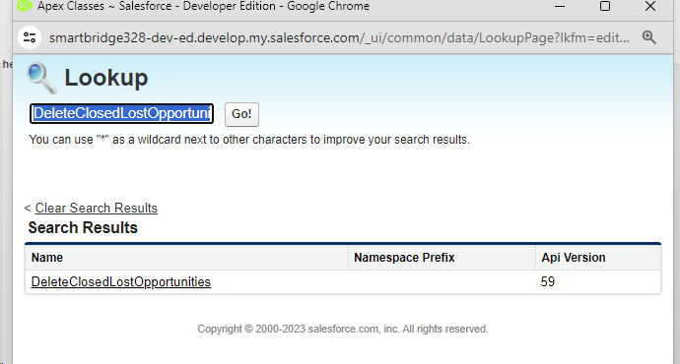

1. In the Schedule Apex section , select weekly and select Monday mentioned and preferred time as 10:00 AM.



1. Click on Save. Now enter Apex in the search box and select Apex jobs.

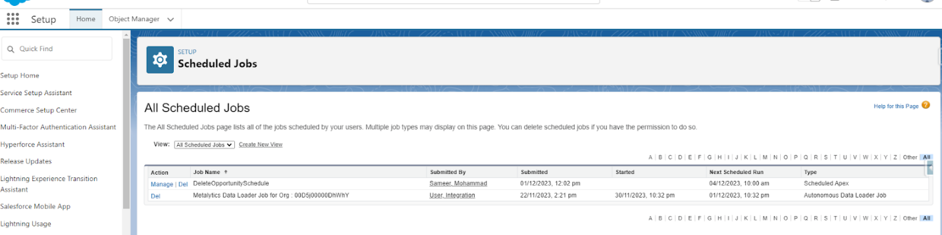

You can see that the batch job is in queue and will run whenever the day mentioned comes.

### 

### Reports

**Create Report On Opportunity**

1. Go to the app >> click on the reports tab
2. Click New Report.

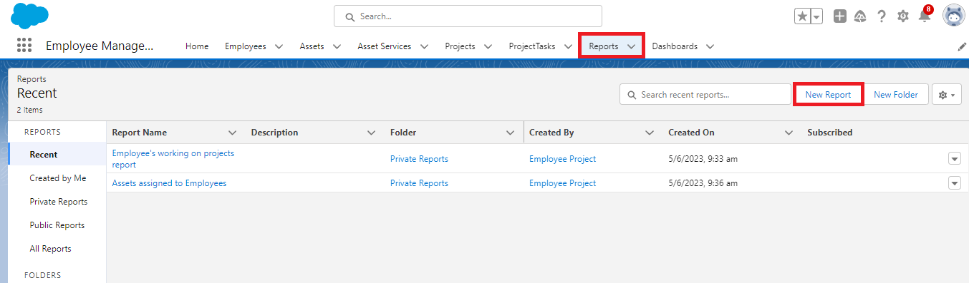

1. Select report type from category or from report type panel or from search panel >> click on start report.

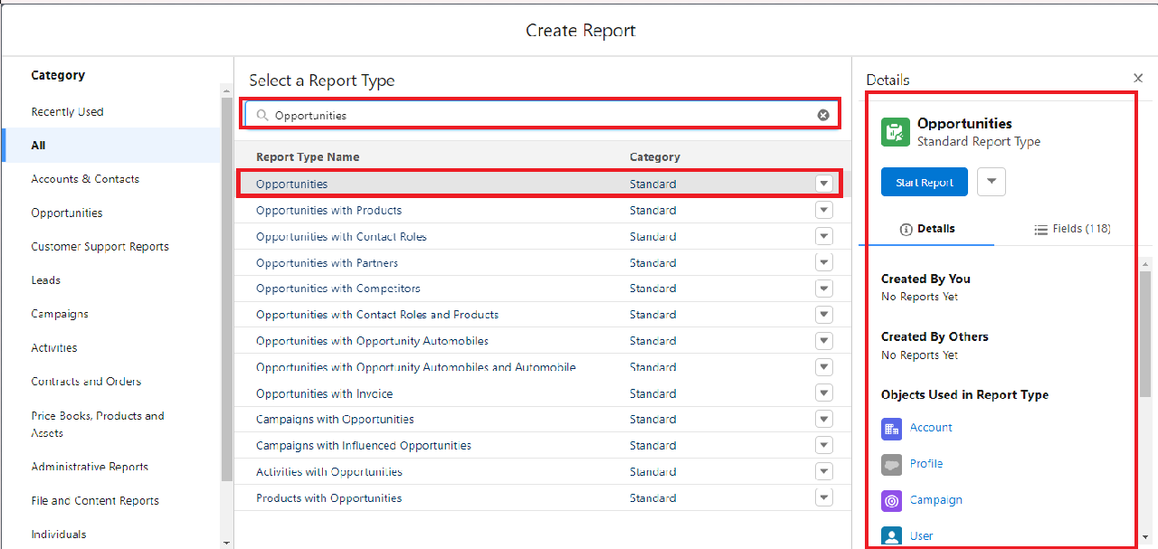

1. Customize your report

* Add fields from left pane as shown below

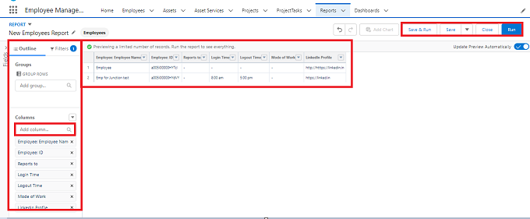

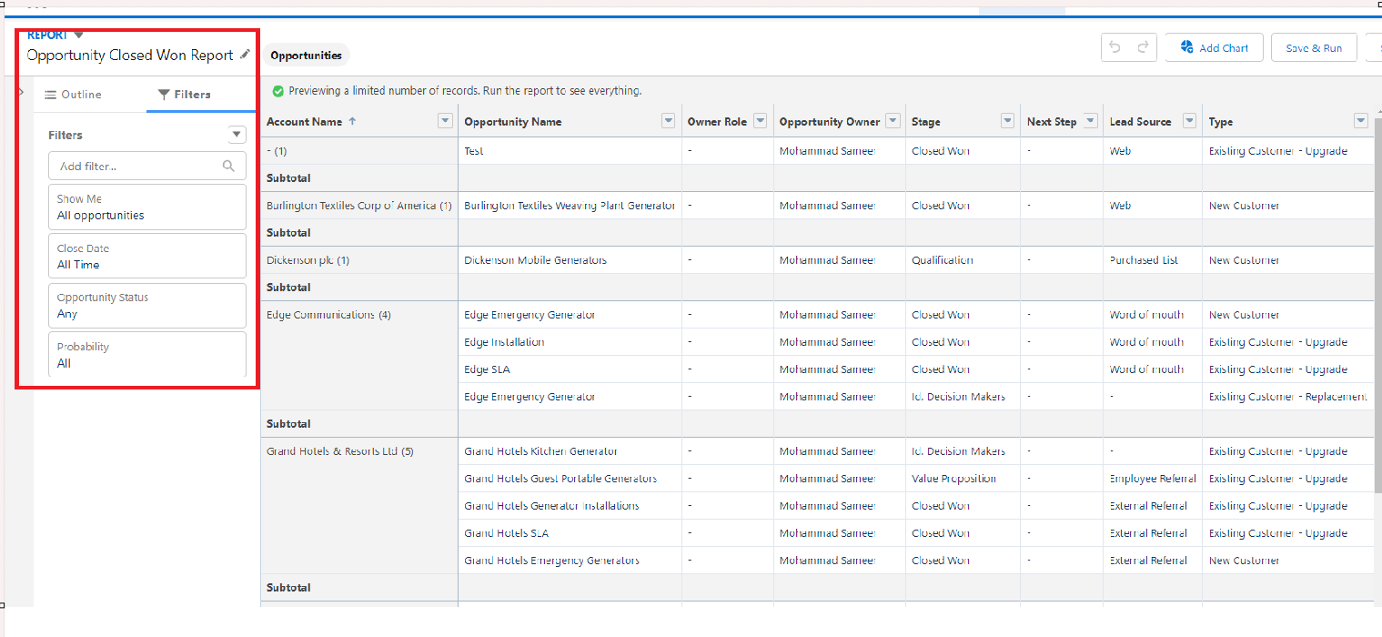

Add the Above Filter as well.

1. Save or run it.

Note: Reports may get varied from the above pictures as the data might be different.

### Create Report On Automobile Information

1. Create a report with a report type: “Automobile Information”.  
     
   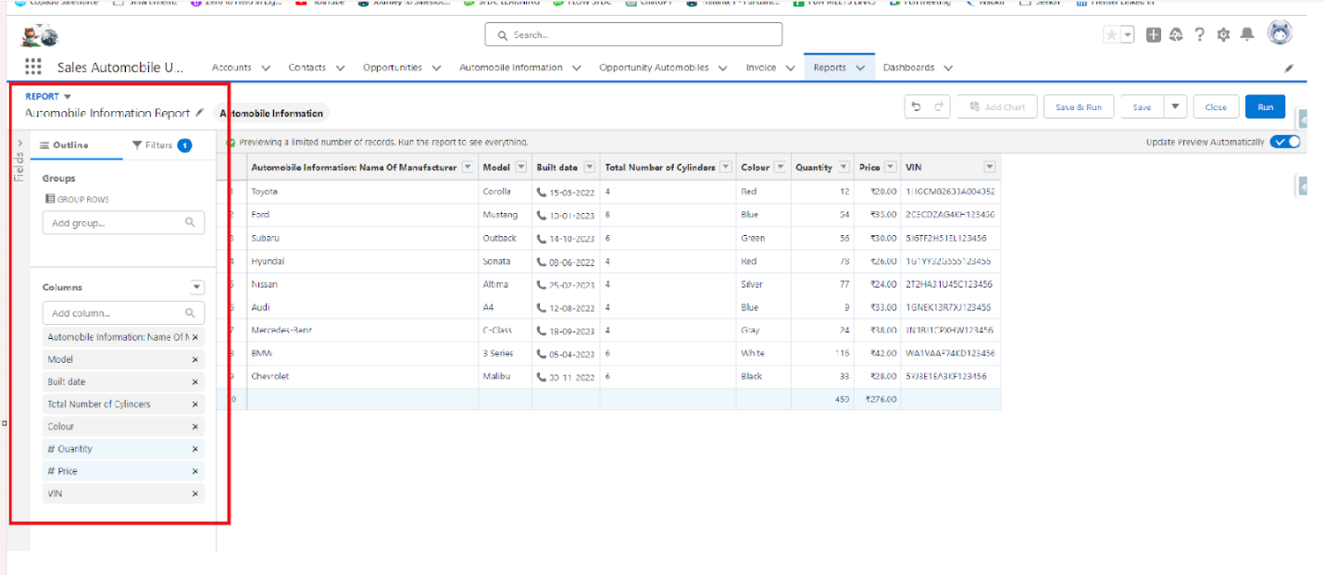  
     
     
   Filters:-  
   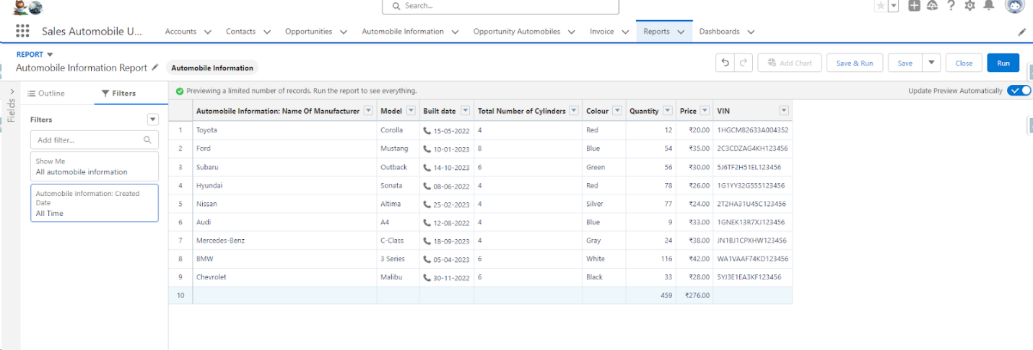
2. Create a Report by using “Opportunities with Opportunity Automobiles and Automobile” Report Type.

### Dashboard

**Sales Dashboard**

Create Dashboard

1. Go to the app ? click on the Dashboards tabs.

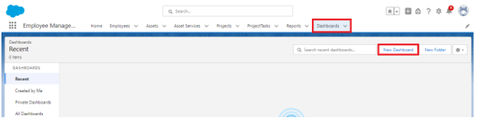

1. Give a Name and click on Create.

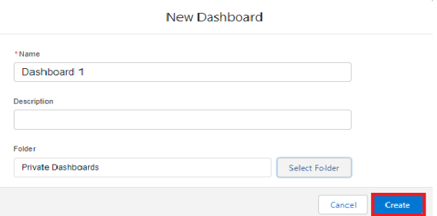

 Name : Automobile Sales

1. Select add component.

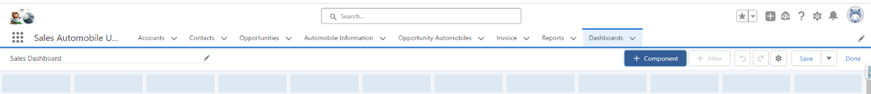

1. Select a Report and click on select.

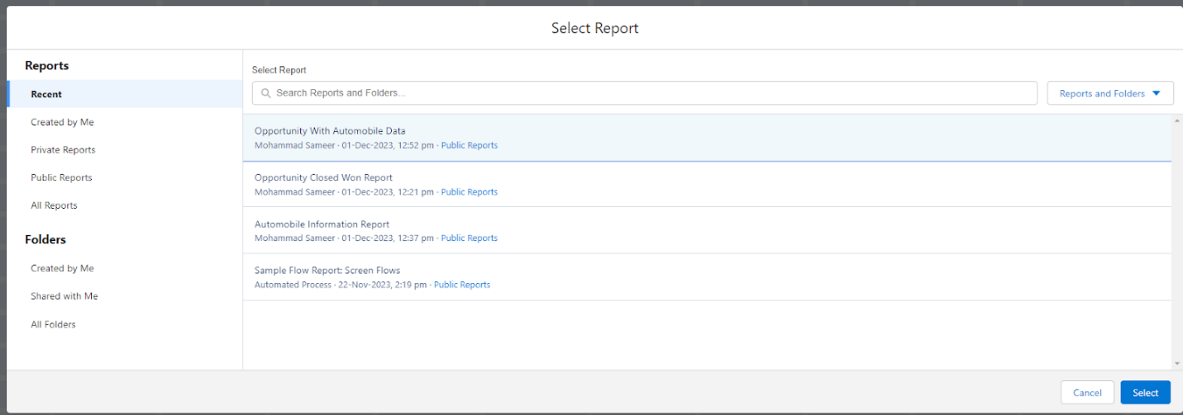

1. Click Add then click on Save and then click on Done.

The Created Dashboard will look like this.

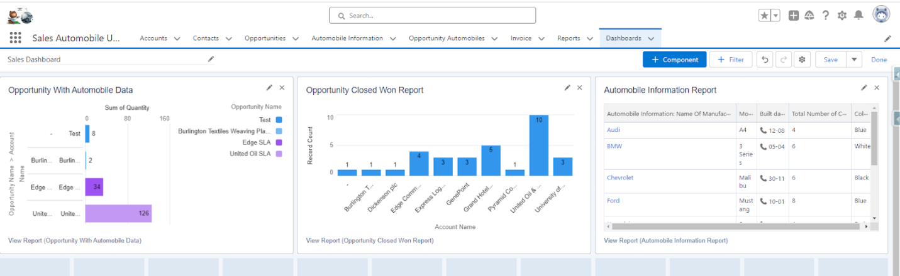

*******************************END****************************